Súkromná stredná odborná škola Dneperská 1,040 01 Košice

ReBooks

User manual

Authors: Vladimír Demko Košice 2016

Miloš Kočan

Matej Pliešovský

Tomáš Tomčík

Content

List of images 3

1 Program description 4

2 Parts of the library system Books 5

3 Installing 6

3.1 Technical requirements 6

3.2 Software requirements 6

3.3 Installation 6

4 The use of ReBooks 9

4.1 Programming interface 9

4.1.1 User 9

4.1.2 Administrator 12

4.2 Web interface 15

# List of images

Img 1: Installation package 6

Img 2: Run installation 7

Img 3: Sellect installation folder 7

Img 4: Installation 8

Img 5: Installation complete 8

Img 6: Sign in form 9

Img 7: Registration 10

Img 8: Interface of user 10

Img 9: Book detail with reservation button 11

Img 10: Editing of profile 11

Img 11: Profile image change 12

Img 12: Administrator interface 12

Img 13: Adding book 13

Img 14: Add category and language of book 13

Img 15: Manage borrowings 14

Img 16: Confirm user registration 14

Img 17: Web Sign in form 15

Img 18: Registration form 15

Img 19: Web page list of books 16

Img 20: Book detail 16

# 1 Program description

Rebooks program is a computer and web application of library's electronic system. Rebooks for the average user provides a web interface as an organized website. For the administrator, there is a computer application, in which the administrator can also switch to the user interface as a regular user. In addition to these interfaces, the application offers also install the system on your computer. After instalation it is not necessary to run it through Visual Studio, in which it was created.

The system administrator can edit the list of books confirm the registration of new users, confirming the booking of books or rejection. He can modify user roles and give them permission administrator or an user. Or he can modify user profiles, edit book information, and add new ones.

Ordinary user can browse a list of books. Furthermore he can borrow books. The user can edit profile and your profile photo.

# 2 Parts of the library system Books

ReBooks system is composed of:

1. Admin interface

* Interface programmed in C # in Visual Studio community consisting of forms

1. User Interface

* Web interface in the form of website
* Interface programmed in C # in Visual Studio community consisting of forms

1. installation package

# 3 Installing

## 3.1 Technical requirements

The application is compatible with all versions of Microsoft Windows. It has no special requirements for software and computer hardware.

Basic minimum hardware requirements: Windows 10 Home

* Procesor Intel Pentium
* 1 GB RAM

## Software requirements

To run the application you need to:

* Install the program using the installation package ReBooks
* Visit the web interface library
  + http://rebooks.aspone.cz/login.aspx

The application interface is done in C#

## Installation

1. Unpack installation package.(Img 1)

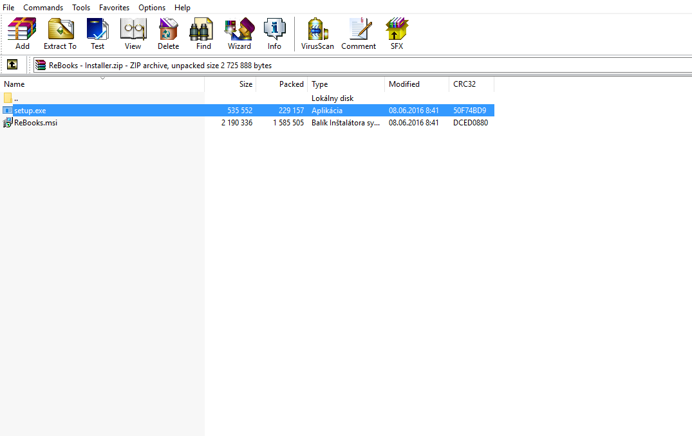

#### Img 1: Installation package

1. Run installation (Img 2)

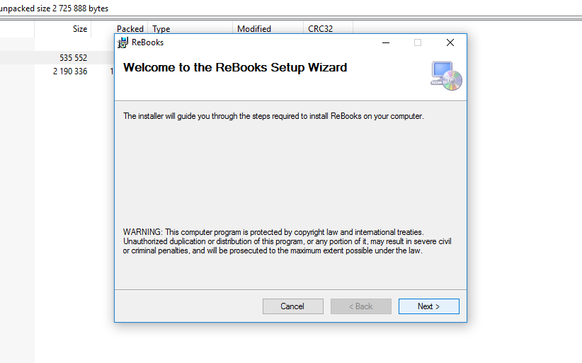

#### Img 2: Run installation

1. Choose folder where program will be install. (Img 3)

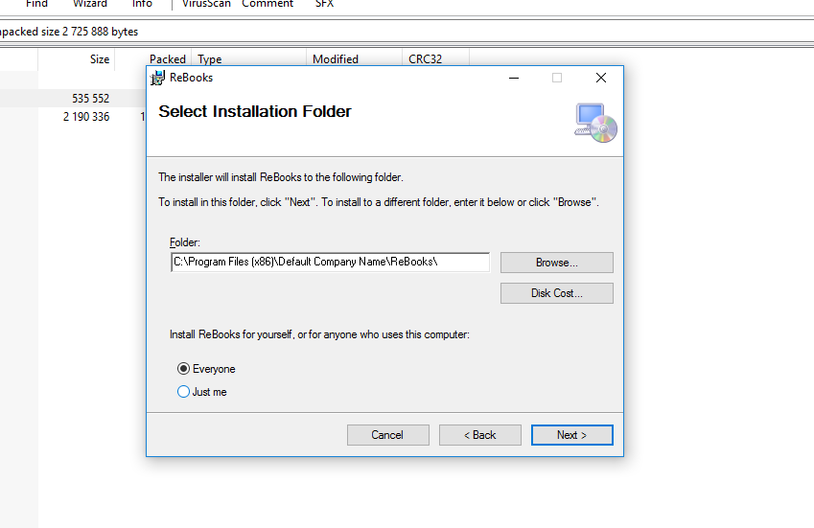

#### Img 3: Sellect installation folder

1. Install program (Img 4)

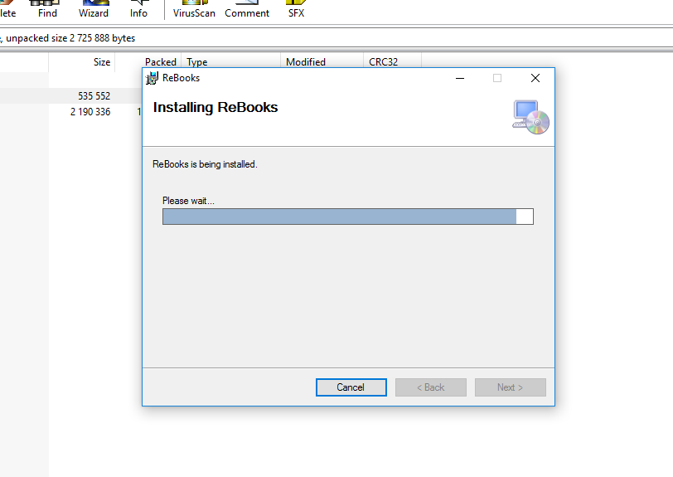

#### Img 4: Installation

1. Finish installation (Img 5)

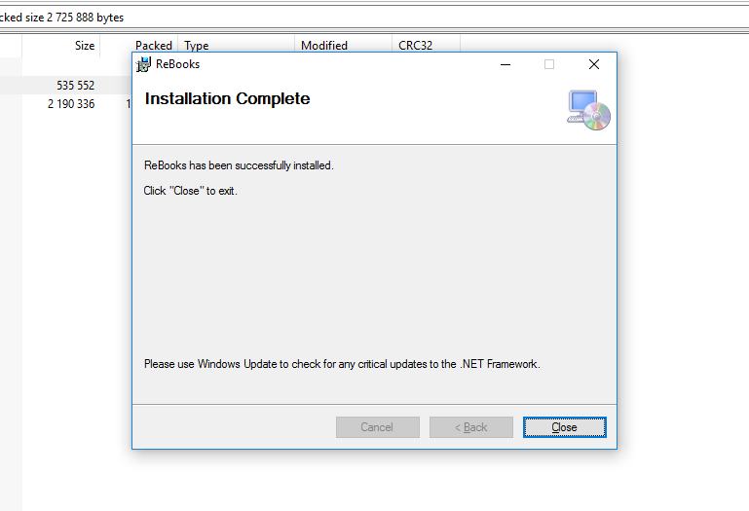

#### Img 5: Installation complete

# 4 The use of ReBooks

## 4.1 Programming interface

### 4.1.1 User

To start, user needs to install the program on computer using the installation package as in chapter 3.3.

After installation when the program ReBooks starts, user can see a welcome page with sign in form. (Img 6)

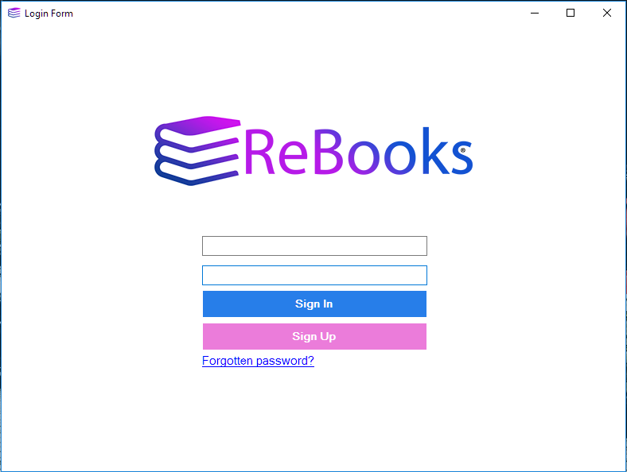

#### Img 6: Sign in form

The user can sign up via registration offer or log in straight if he is already registered. (Img 7)

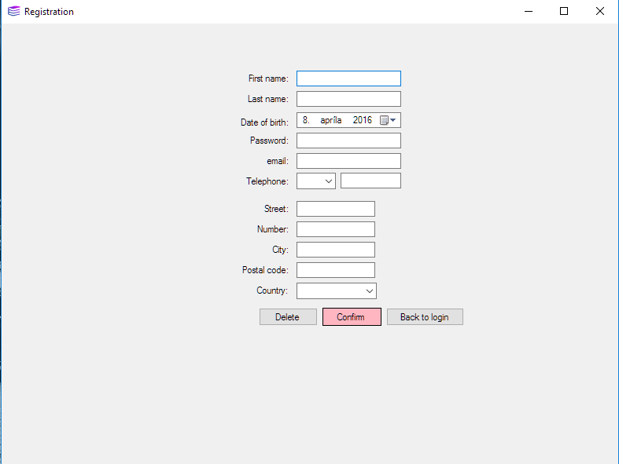

#### Img 7: Registration

Upon successful login, it opens interface of the user. (Img 8)

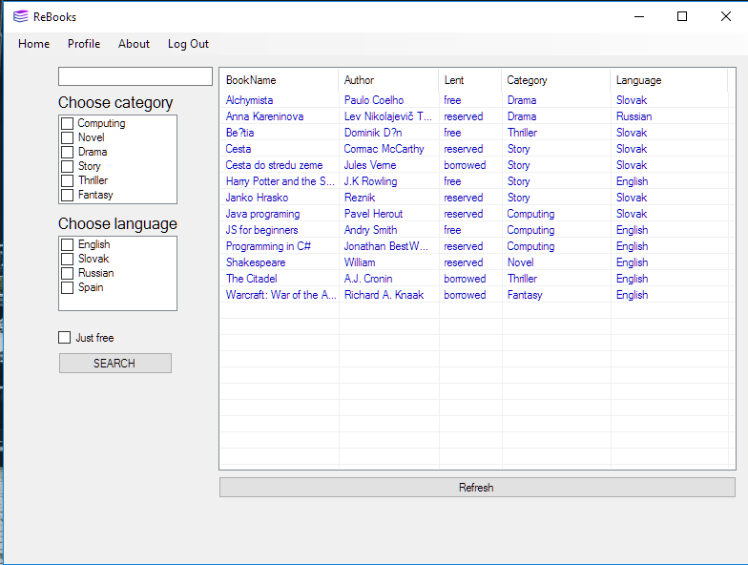

#### Img 8: Interface of user

When a user first registers he must wait for confirmation of registration by administrator.

When administrator has enabled user registration user can browse the books.

In addition to browsing books he can books a book. (Img 9)

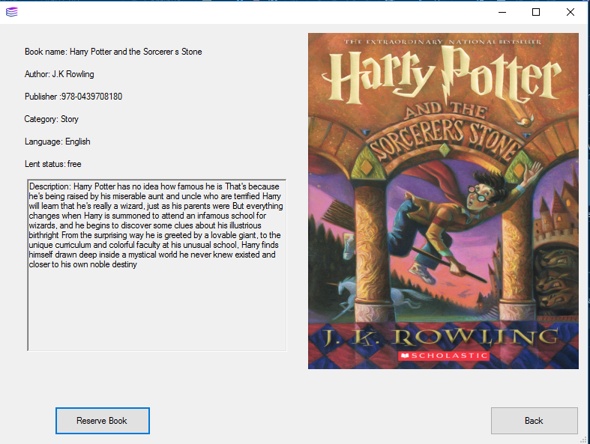

#### Img 9: Book detail with reservation button

All book reservations must be enabled by administrator. The user can also cancel the reservation of book.

The user can also edit his profile. (Img 10) He can also edit his profile picture. (Img 11)

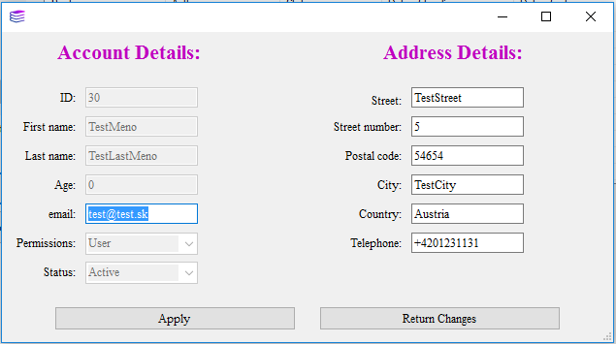

#### Img 10: Editing of profile

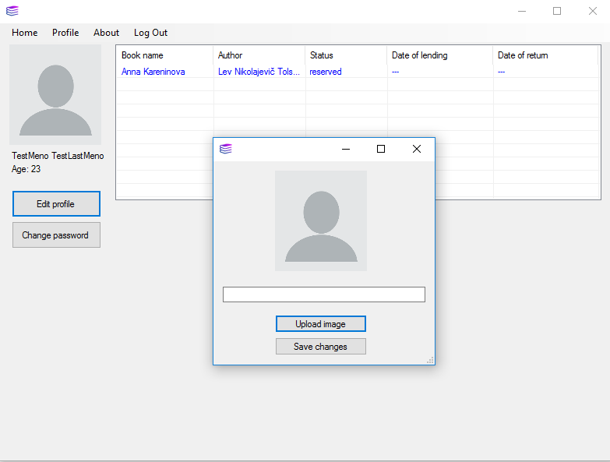

#### Img 11: Profile image change

### 4.1.2 Administrator

To start, administrator needs to install the program on computer using the installation package as in chapter 3.3. After installation when the program ReBooks starts, administrator can see a welcome page with sign in form.

Upon successful login, it opens administrator interface. (Img 12)

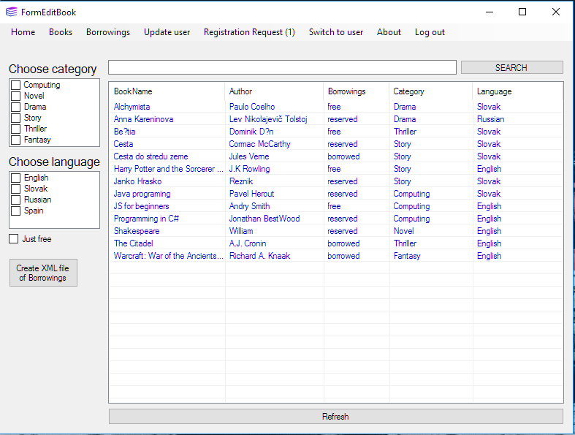

#### Img 12: Administrator interface

Administrator can add new books. (Img 13) He can add new book categories and languages. (Img 14)

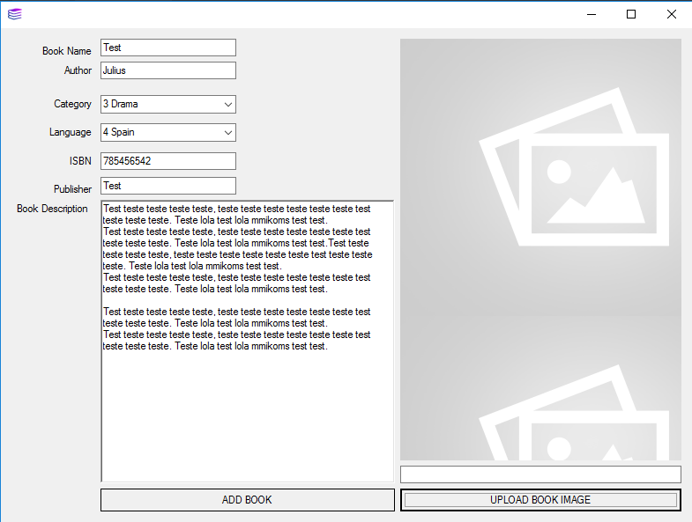

#### Img 13: Adding book

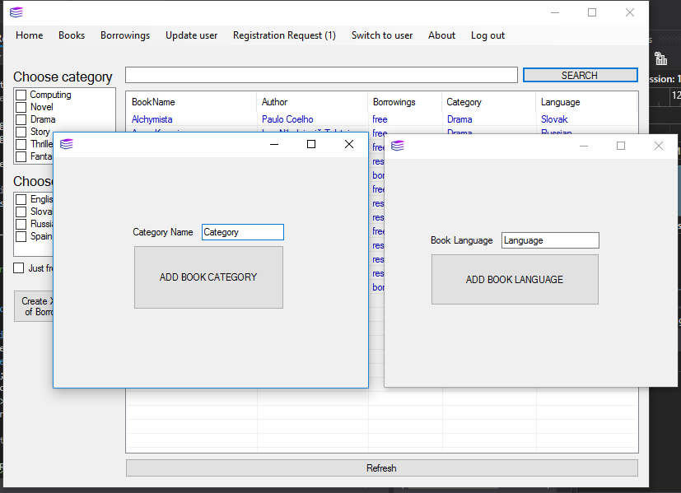

#### Img 14: Add category and language of book

He can also manage borrowings and confirm new borrowings of users. (Img 15)

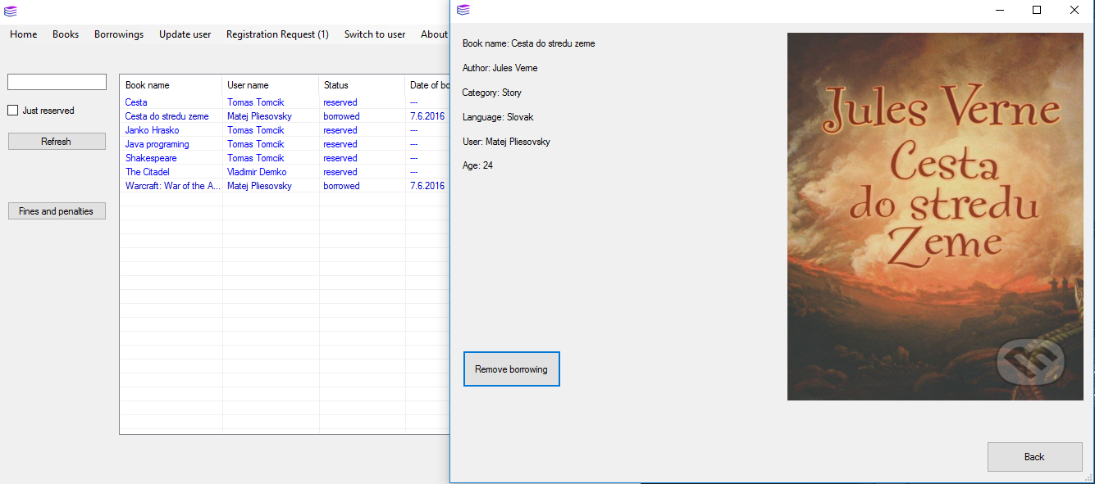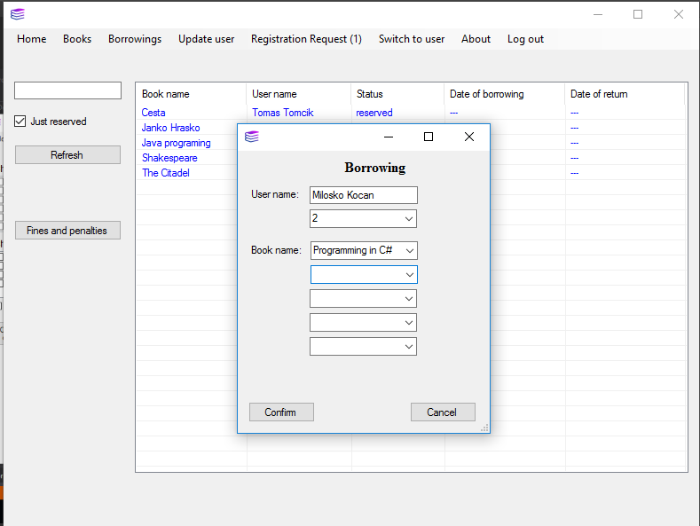

#### Img 15: Manage borrowings

Administrator can confirm user registration. (Img 16)

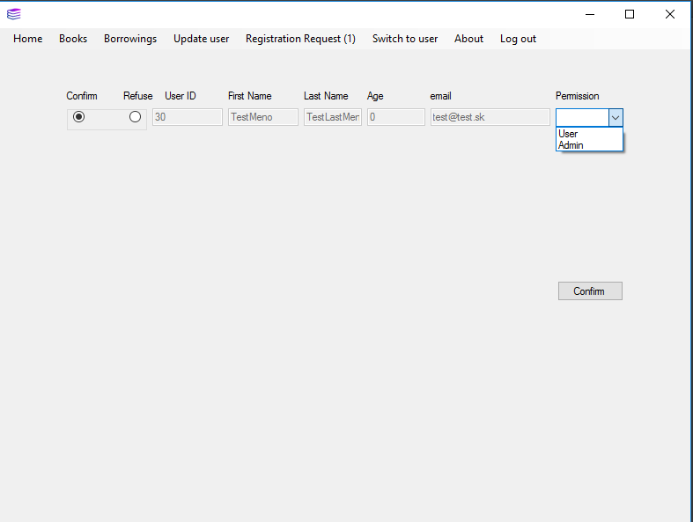

#### Img 16: Confirm user registration

Administrator can edit user profile and add permissions to users.

Administrator can switch to user mode and borrow books or edit his profile as user. Then he can return to administrator mode.

## 4.2 Web interface

The web interface of the system is designed for ordinary user just to browse through a list of books and a borrowings.

User after entering the Web site to the browser sees the login page. On this page you also may choose the registration. Then he opens the registration form. (Img 17)

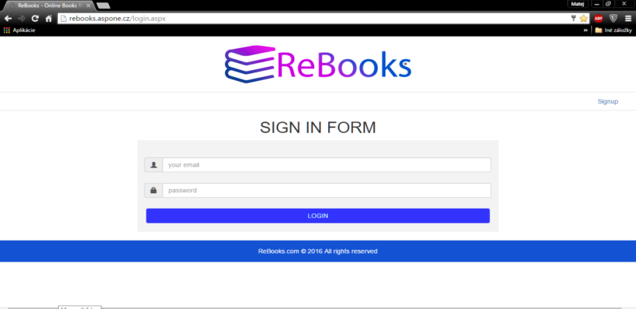

#### Img 17: Web Sign in form

After correct filling out the registration form, registration is sent. Then user waits for confirmation by the administrator.(Img 18)

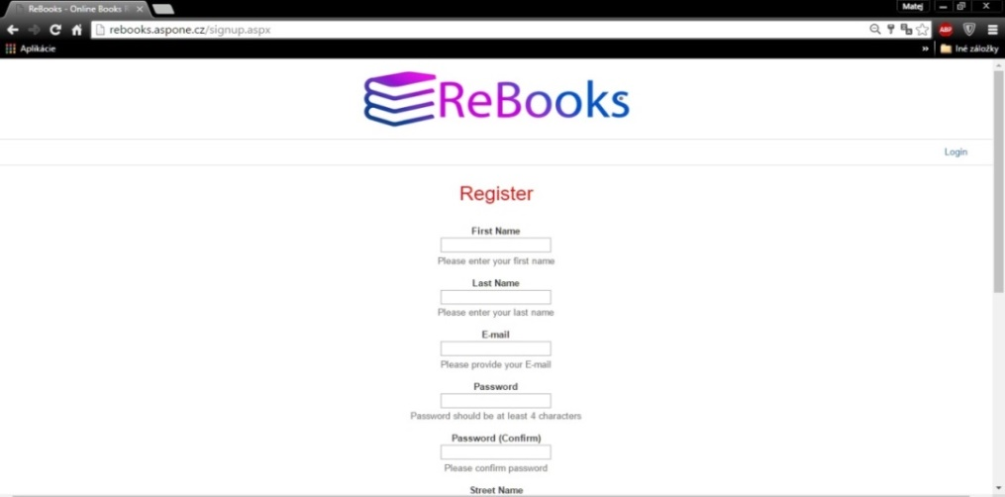

#### Img 18: Registration form

If user logs into the system as confirmed user, he fills in the username and password. After a successful login page opens with a list of books. The user than can browse and borrow books. (Img 19)

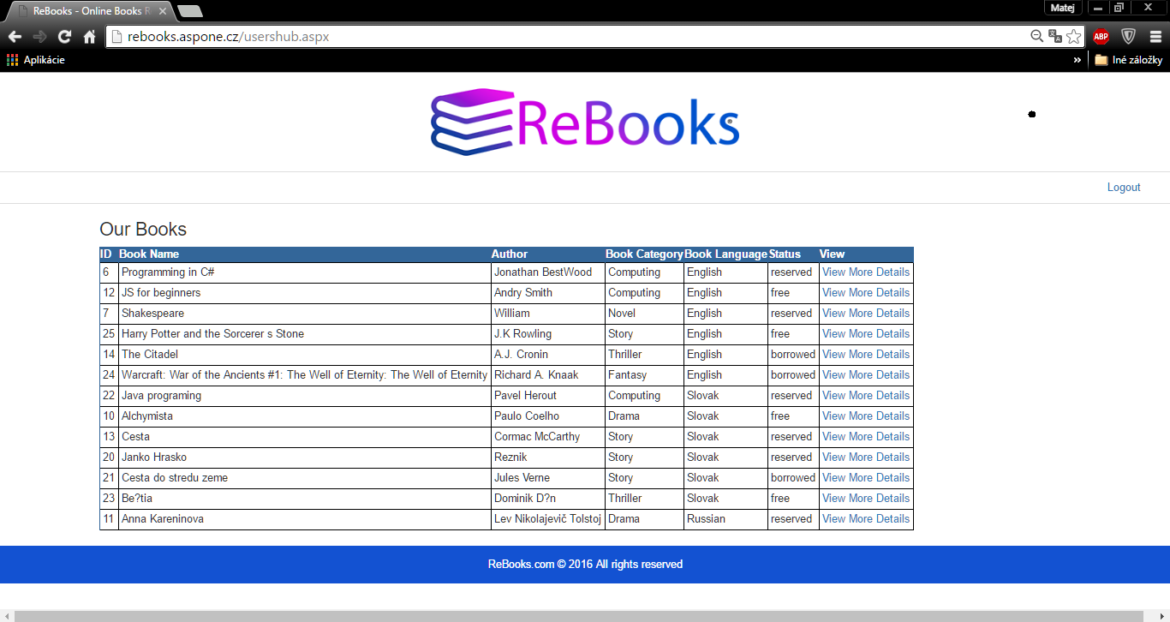

#### Img 19: Web page list of books

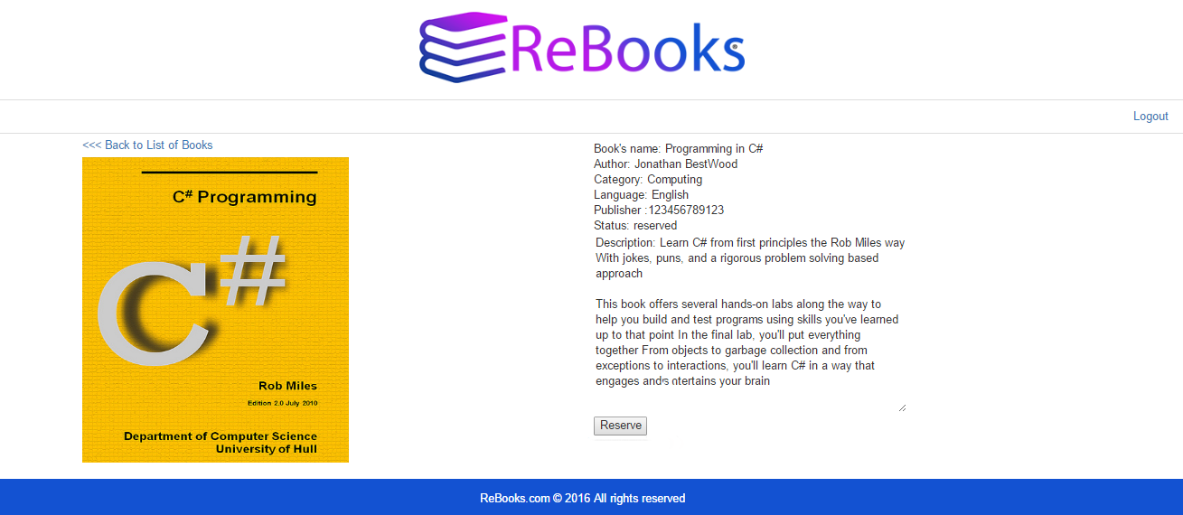

#### Img 20: Book detail